LAB 8 – Docker and containers

A container is a standard unit of software that packages up code and all its dependencies so the application runs quickly and reliably from one computing environment to another. A Docker container image is a lightweight, standalone, executable package of software that includes everything needed to run an application: code, runtime, system tools, system libraries and settings.
Container images become containers at runtime and in the case of Docker containers – images become containers when they run on Docker Engine. Available for both Linux and Windows-based applications, containerized software will always run the same, regardless of the infrastructure. Containers isolate software from its environment and ensure that it works uniformly despite differences for instance between development and staging.

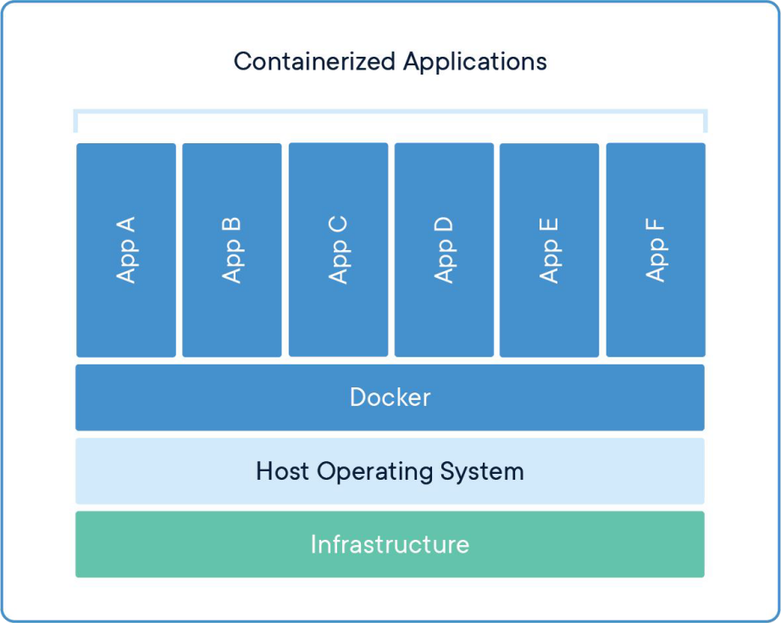

A docker image, on the other hand, is a blueprint that specifies how to run an application. In order for Docker to build images automatically, a set of instructions must be stored in a special file known as a Dockerfile.

Install Docker

https://docs.docker.com/engine/install/

Build and run your first container
Create a sample “hello world” flask app.
Within the root directory, run the below command in the terminal:
pip freeze > requirements.txt
This will generate the names of the packages and their respective versions that you have installed, as well as some other inbuilt dependencies that run your Flask application. Then, it stores them in a .txt file named requirements.
Depending on the complexity of your project and the packages you have installed, the content of this file will vary from project to project.
Create a file in your code directory and name it Dockerfile. Add the following code snippet to the file:

# start by pulling the python image FROM python:3.8-alpine
# copy the requirements file into the image COPY ./requirements.txt /app/requirements.txt # switch working directory
WORKDIR /app
# install the dependencies and packages in the requirements file RUN pip install -r requirements.txt
# copy every content from the local file to the image COPY . /app
CMD ["python3", "app.py"]

Let’s go over the instructions in this Dockerfile:
FROM python:3.8-alpine: Since Docker allows us to inherit existing images, we install a Python image and install it in our Docker image. Alpine is a lightweight Linux distro that will serve as the OS on which we install our image
COPY ./requirements.txt /app/requirements.txt: Here, we copy the requirements file and its content (the generated packages and dependencies) into the app folder of the image

WORKDIR /app: We proceed to set the working directory as /app, which will be the root directory of our application in the container
RUN pip install -r requirements.txt: This command installs all the dependencies defined in the requirements.txt file into our application within the container
COPY . /app: This copies every other file and its respective contents into the app folder that is the root directory of our application within the container
- Build the Docker image
Let’s proceed to build the image with the command below:
docker image build -t flask_docker .
- Run the container
After successfully building the image, the next step is to run an instance of the image. Here is how to perform this:
docker run -p 5000:5000 -d flask_docker
This command runs the container and its embedded application, each on port 5000 using a port-binding approach. The first 5000 is the port that we allocate to the container on our machine. The second 5000 is the port where the application will run on the container.

Activity -1 to be graded
Try the following commands and take a snapshot of the results after running each command. In a statement, write what does each command do.
docker ps -a
docker stop <image_name> docker logs <image_name>

Upload a word document containing snapshots and explanations to moodle. Activity-2 to be graded
Build two container images and take a snapshot of each image in docker desktop as per the below snapshot:
- One that runs lab5-Postman and APIs on port 5000 to be called as your username/ lab8- FirstName_LastName of tag 0.0.1:RELEASE. Your username should be your aub username, I.e.mine should have been ig12 instead of imangh84.

- One that run on port 3000 and exposes an API get_users (Get method), that gets a list of all the names of the users in the database to be called as your username/ lab8-FirstName_LastName of


Faculty of Engineering and Architecture Software Tools Lab - Fall 2024 2025

tag 0.0.2:RELEASE.Your username should be your aub username, I.e.mine should have been ig12 instead of imangh84.
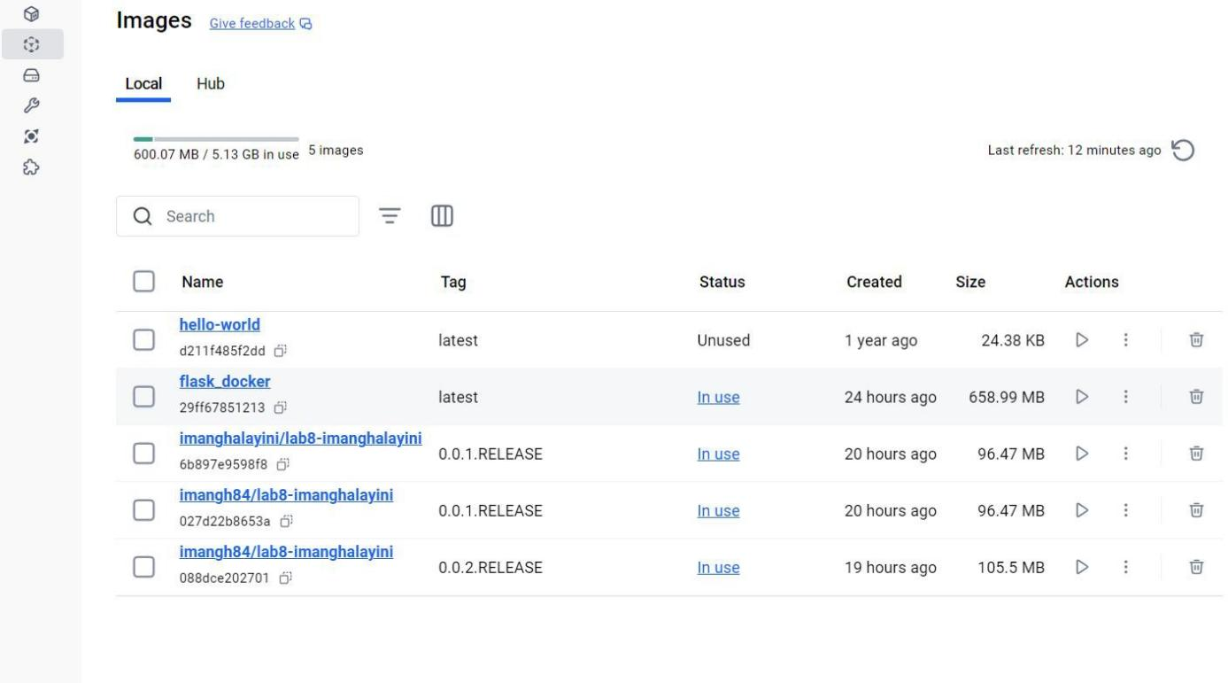

Upload your zipped code and snapshots needed to moodle.

